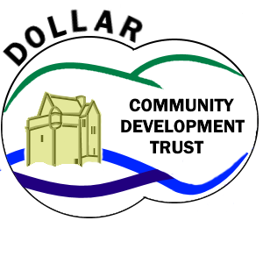
Comments, Suggestions and Complaints

How can I make a comment, suggestion or complaint?

We want you to tell us how we are doing, what we can do even better and, if you think we are getting things wrong.

Please, share your ideas on how we can improve so that we can provide the best service possible for the people of Dollar via our Comments, Suggestions and Complaints form.

There are Comments, Suggestions and Complaints forms like this one available at our office* or the Civic Centre. You can use this form to tell us about an issue or, if you would prefer, you can speak directly to any of the trustees.

You do not have to fill in your name and address if you would prefer to remain anonymous though, if you wish to receive a response, we will require some way of getting in touch with you.

If you have made a formal complaint, and given your details, you will be contacted within 7 days. We aim to resolve all formal complaints within 30 days or advise of any special circumstances which may prevent us from doing so.

Thank you for your feedback!

- Dollar Community Development Trust

Comments, Suggestions and Complaints Form

Personal Details (Required only if you wish a response) :
Name: |  | Date:

Address:

Tel No: |  | Email:

Comment, Suggestion, complaint*:

What action would you like us to take*? :

Please place this form in the feedback box at either our office or the Civic Centre. You can also hand the form in to any trustee in person or deliver it to 7 The Ness, Dollar, FK14 7EB
*add further sheet if required

